DAY8 SESSION ASSIGNMENTS (Theory)

1. When to use (Rapid Application Development) RAD model
When not to use (Rapid Application Development) RAD model?

ANS:

RAD model is Rapid Application Development model. In RAD model the components are developed in parallel . It is adoption of waterfall model,it aims at developing a software
in a short span of time.

When to use RAD model:
- RAD should be used when there is a need to create a system that can be modularized in 2-3 months of time.
- It should be used if there’s high availability of designers for modeling and the budget is high enough to afford their cost along with the cost of automated code generating tools.
- RAD S DLC model should be chosen only if resources with high business knowledge are available and there is a need to produce the system in a short span of time.
- Suitable for systems that are component based and scalable.
When not to use RAD model:
- RAD model is not suitable for projects that requires long development times.
- RAD is not used where user involvement is not practical
- RAD is not used for cheaper projects as cost of modeling and automated code generation is very high.

2. Define an ER diagram of a software Organization with all the relationship
model that was discussed in the classroom.

ANS:

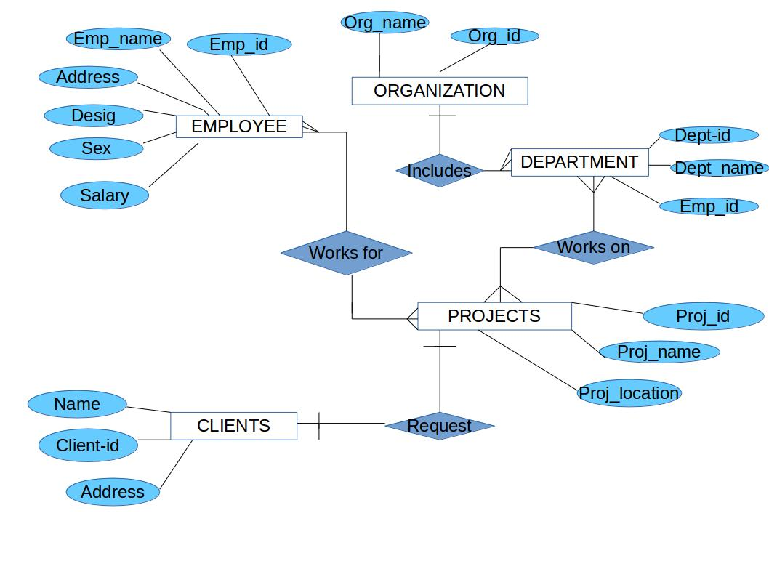

3. Describe the Entity Relationships for the following diagram

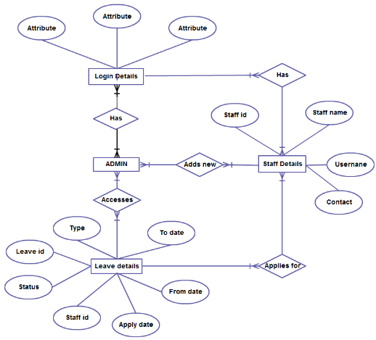

ANS:

In the above ER diagram there are 4 entites,they are:-
- ADMIN
- login details
- staff details
- leave details
- Staff details

- Within the staff details entity, the available attributes are staffname,staffid,username,contact
- Admin can add new details to staff details
- Staff details can also apply for leave details
- Staff details is available at login details too

- Leave details

- Within the leave details entity ,the available attributes are type,leave id,status,staff id,apply date,from date, to date.
- ADMIN has an acess to leave details and thus he is responsible for processing the leave request given by staff details

- Login details

- Login details can have many attributes like username,password etc

- ADMIN

- ADMIN have a many to many relationship with other entites

